**Smart Tech Solution Pvt. Ltd.**

Thapagaun, New Baneshwor

Kathmandu, Nepal

+977 - 01 - 5245027

**User Manual**

**For**

**Asset Management**

**Dashboard ( Web )**

# 

1. Background 3

1.1 Assets 3

1.2 Maintenance 3

1.3 Service level 3

1.4 Asset Management 3

2. Asset Management Plan 3

3. Introduction 4

4. The Web Dashboard 5

a. Home 6

b. Finance 6

c. Maintenance 7

d. Service 7

5. Using Web Dashboard 8

5.1 Home 9

5.1.1 Income & Expenditure Visualization 9

5.1.1.1 All Time 9

5.1.1.2 This year 10

5.1.2 Maintenance Cost Visualization 11

5.1.2.1 All Time 11

5.1.2.2 This year 12

13

5.2 Finance 13

5.2.1 Visualization 13

5.2.1.1 All Time 13

5.2.1.2 This Year 14

5.2.2 Actual Income/Expenditure (Cashbook) 15

5.3 Maintenance 17

5.3.1 Cost Visualization 17

5.3.1.1 All Time 17

5.3.1.2 This Year 18

5.3.2 Expected risks, activities & Cost 19

5.4 Service 20

5.4.1 Supply Visualization 20

5.4.2 Quality Test Result 22

5.4.2.1 Quality Test Result 22

5.5 Change Language 24

5.6 Logout 24

# 

# 1. Background

The asset management tools comprising a mobile app, a web dashboard, and a configuration panel are developed to support the management of assets and making asset management plans for water systems. To completely understand the concepts of asset management and the use of these tools, there is an entire e-learning platform that can be accessed at the following URL. <https://elearning.assetmgmttool.com/>

Following is a brief introduction to important concepts of asset management to help users understand different features of the tools while going through this manual.

## 1.1 Assets

An asset is a useful object or one of its components that is expected to provide benefits to the user, a person, or a company. For water systems, assets are the physical components of the system that allow for reliable, and safe water supply to the users. For example, wells, filtration units such as chlorination tanks, sedimentation tanks, roughing filters, hydrants, pipes, valves, bolts, overhead tanks, pumps, and household taps with meters.

## 1.2 Maintenance

Maintenance is the activity to ensure that assets keep on fulfilling their intended function during their full lifetime. Maintenance is important to reduce the risk of failure, ensure the system is reliable, and (in the case of water systems) provide clean water continuously to end-users.

## 1.3 Service level

The service level (SL) of a water system is the agreed quantity and quality of water supply during a certain time.

## 1.4 Asset Management

Asset management is the activity of maintaining the agreed service level during a sustained period of time at a certain cost.

# 2. Asset Management Plan

An Asset Management Plan is developed by applying a community-led approach and supports stakeholders to ensure the required service level during a period of time. It includes:

1. An asset inventory

2. A risk assessment

3. A maintenance plan

4. An income and optimization analysis: A financial projection of what income (= water tariff and extra-governmental or charity contributions) is required to cover the costs for the agreed SL.

An Asset Management plan needs to be updated regularly since financial projections might not match reality, or some maintenance might be unforeseen and not included in the plan and cost estimates.

# 3. Introduction

Asset management tools for individual water system includes the following,

1. A mobile app

2. A web dashboard

3. A configuration panel

The mobile app is a password-protected application that allows operational staff members of the water system to view and add information into the water system. The web dashboard is a publicly accessible web link that presents information about the water system. The configuration panel in the password-protected data management area for the entire system. Data and settings for the water system can be managed from the configuration area.

When a new water system is added, a web dashboard link and a user for configuration panel is created. Users for mobile applications can be then created from the configuration panel.

The entire tool set focuses on 3 major areas of asset management for water systems, finance, maintenance, and service.

The configuration panel is used to manage general information about the water system, expected and actual income and expenditure, asset components with lifespan, risks and costs, and quality test parameters. The mobile app lets staff members fill in actual monthly transactions, view lists of asset components for maintenance and fill in maintenance logs, add water supply records and add water test results. The web dashboard combines data from both the configuration panel and the mobile app to present a visualization of finance, maintenance and service data of the water system.

# 

# 4. The Web Dashboard

This manual guides user to use the web dashboard of the asset management tools. The web dashboard is a publicly accessible web link that is unique for each water system. The unique URL for the web dashboard will be generated when a scheme is created in the system. The scheme-name in the following URL will have the name of the scheme created. The web dashboard is available to all the people. No authentication/login is required to view the web dashboard for any schemes. Water scheme community can share the unique URL to anyone.  
Web dashboard URL example:  
[https://assetmanagementsystem.netlify.app/#/scheme/scheme-name/home](https://assetmanagementsystem.netlify.app/#/scheme/lubhu-test/home)

**From where the data in the Web Dashboard is coming?**

As explained, the web dashboard is a visualization of financial, maintenance, and service data of the water supply system. The data available in the web dashboard have been entered by water scheme caretakers or managers via the configuration panel and mobile app. The dashboard visualizes both forecasted data that might occur and actual numbers that have occurred during water systems’ operation. Some definitions:

* Beneficiary:  
  Beneficiaries are the users of the water system.
* Finance:  
  Finance relates to income and expenditure in terms of monetary transactions . Data in Income and Expenditure are on the basis that it has occurred(Actual) during operation and might occur (Expected) during/in a certain period of time.
* Maintenance:  
  Maintenance is the activity to ensure that assets keep on fulfilling their intended function during their full lifetime. Maintenance is important to reduce the risk of failure, ensure the system is reliable, and (in the case of water systems) provide clean water continuously to end-users. A Maintenance plan is created for the various asset components of the water scheme. Each asset receives a prediction of the type of maintenance activities needed in the future.

Maintenance costs can be separated into unsegregated (in total) and segregated (Consumable, Labor, and Replacement) costs.

Consumable: is the expected cost of goods and repair costs required to fix machineries and other necessary equipment required for regular maintenance .  
Labor: is the estimated cost of laborers required for maintenance.  
Replacement: is the estimated cost of complete replacement of machines or equipment after their failure.

Expected unsegregated and segregated costs are the costs that have been predicted during the creation of the maintenance cycle.

Actual unsegregated and segregated costs are the costs that have actually occurred during the maintenance.

* Service:  
  Supply Visualization includes the water supply data. Revenue water is the revenue generated from the sales of water collected from its beneficiaries. Non-revenue water is the water lost during water transmission and water not being paid for by customers: calculated on the basis of water distributed from the system and the revenue generated from the sales. The difference between those two is considered to be non-revenue water.   
  Quality Test Result displays the data of tested water during a certain period of time. It compares the test data with National Drinking Water Quality (NDWQ) Standards for water quality assurance purposes. .

*Note: All the data in Data References are the input by the operational stakeholders of the water scheme through special Configuration Panel and Mobile Application.*

The web dashboard has four major sections, home, finance, maintenance, and service. A detailed explanation of each function under each section is present in the corresponding section of this manual. A basic overview of functions under each section is as follows:

## Home

i. Presents a summary of the water system . This includes general information about the system, beneficiary information, and supply information from the home screen of the configuration panel. In addition, it has a display of net financial balance calculated from actual income and expenditure entered into the system, from either the configuration panel or the mobile app.

ii. It also presents a summary visualization of income and expenditure that can be viewed for all times or for the present year. The income and expenditure data comes from either the cash book entry of the configuration panel or the cash book entry of the mobile app.

iii. It also presents a summary visualization of executed and expected maintenance costs for all times and for the present year. The expected maintenance cost comes from the maintenance section of the configuration panel and the actual cost comes from the maintenance logs added from the configuration panel or the mobile app.

## Finance

Finance has two sub-sections: i) visualization, and ii) cashbook.

i. Visualization presents the financial parameters in visual graphics to facilitate their comprehension. The parameters include: actual income, actual expenditure, and actual cumulative cash flow. The same applies for expected income, expected expenditure, and expected cumulative cash flow. Users can select/unselect parameters of their choice to view and compare. The distribution of actual income and expenditure is also presented. Actual income and expenditure comes from cash book entries from the configuration panel or the mobile app. Expected income and expenditures come from the expected income (tariff rates) and expected income/expenditure (others) entries in the configuration panel. The cumulative cash flows are the calculation of the cumulative difference of income and expenditure.

ii. Cashbook is the record of actual transactions as entered in the system (entries can be done from the mobile application and the configuration panel). By default, the cashbook for the current month is visible. Users can switch to a different month or view transactions for a date range of their choice.

## Maintenance

Maintenance has two sub-sections: i) data visualization and ii) expected risk, activities & cost..

i. Cost Visualization presents a visualization of maintenance costs, this includes expected and actual maintenance costs. Expected maintenance cost is added from the expected risk, activities and costs section inside maintenance in the configuration panel. Actual maintenance cost comes from maintenance logs added either from the Actual maintenance section inside maintenance in the configuration panel or maintenance logs added from the mobile app under maintenance tab. The costs are added as a whole or separated under different maintenance cost categories. For example, if the cost of labor, consumables and/or replacement is known for a specific maintenance then these are added under respective titles. But if separate costs are not known for a maintenance action, it is added as a whole. These two options for cost addition are mutually exclusive. The total cost of maintenance is the sum of all costs. Users can select/deselect parameters of their choice to view and compare. The distribution of costs under different categories is also presented.

ii. Expected risk, activities & cost, presents the asset components lists with its risk evaluation, maintenance costs, and mitigation measures information ( all the data can be entered through the configuration panel under the section Maintenance).

## Service

Service has two sub-sections: i) supply visualization, and ii) quality test results.

i. Supply visualization presents graphical representations of actual water supplied and water sold. These data can be added from the service supply tab (for water entering the distribution system) and the cash book tab (for water sold) in the mobile application (but can also be managed from the service tab in the configuration panel) respectively. The visualization also presents an estimate of non-revenue water. Non-revenue water is the difference between total water supplied and the volume of water for which revenue is earned. For example, if the record of volume of water supplied, in a particular period is 1000Liters and the record of volume of water sold for the same period is 950Liters then non-revenue water for that period will be 1000-950 = 50Liters.

ii. Quality test results present a visualization of actual quality test results as added from the mobile application. The test parameters are configurable from the configuration panel.

**Title bar**

In addition to these features, users can switch between English and Nepali language from the title bar in the top right corner at anytime while using the system. The title bar also has a help function and an option to log-out.

# 5. Using Web Dashboard

When a Water System’s User logs into the web application, the Dashboard is the first screen he/she will see.

## 

## 

## 5.1 Home

In the Dashboard’s Home tab, users can view the Overall Net Balance, General Information, Beneficiary details, Supply Schedule, Tariff rates, a Graph visualization of Income and Expenditures and a Graph Maintenance costs of the Water System. In the following two sections, the graphical visualizations are explained. 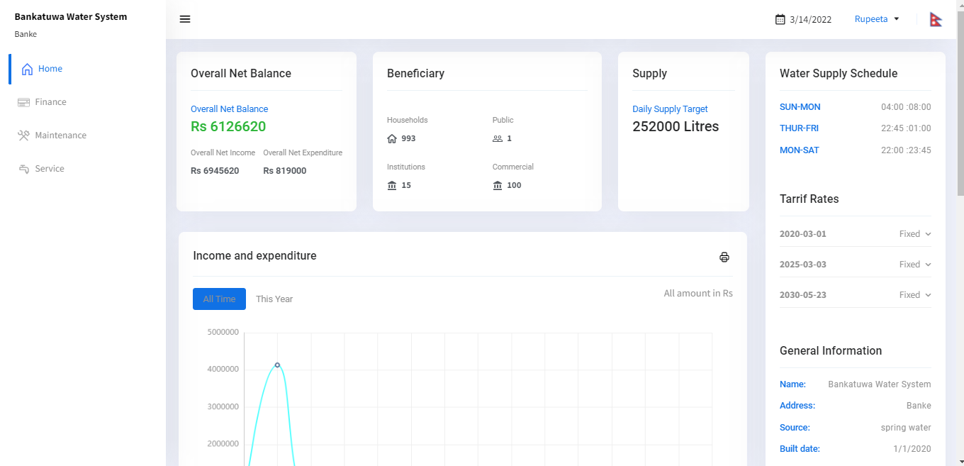

### 5.1.1 Income & Expenditure Visualization

In the Visualization Graph of Income & Expenditure, users can view the Income and Expenditure of different years with respective months of the water system. There is a visualization graph for:

1. All Time
2. This Year

#### 

#### 5.1.1.1 All Time

In the All-time visualization graph, users can view the income and expenditure for the different years only. If the user clicks on the graph for Year 1, then he/she will be able to see the total income and expenses for that year. Likewise, to view other Years’ income and expenditure, users can click on the graph of different years.

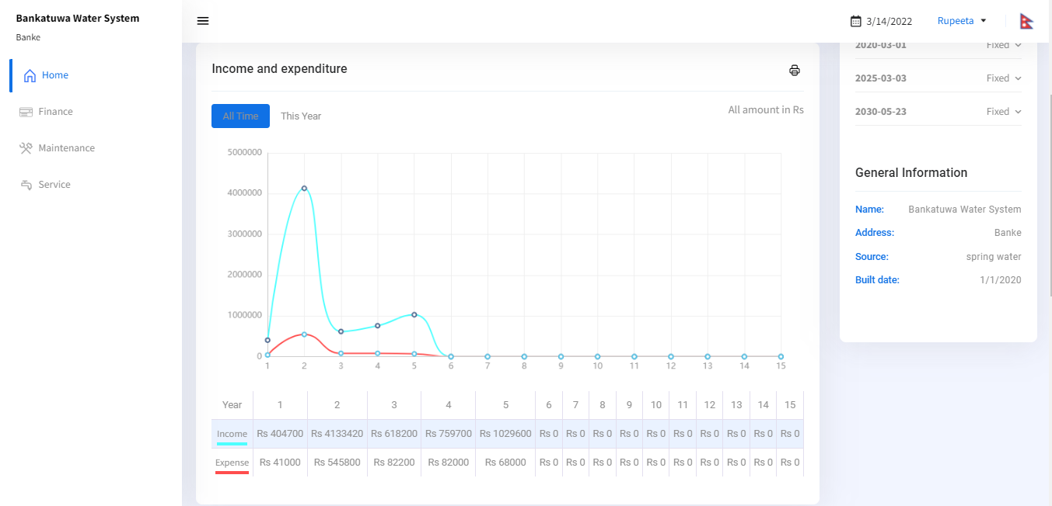

#### 5.1.1.2 This year

In This year's visualization graph, users can view the income and expenditure for the current year within the respective months.

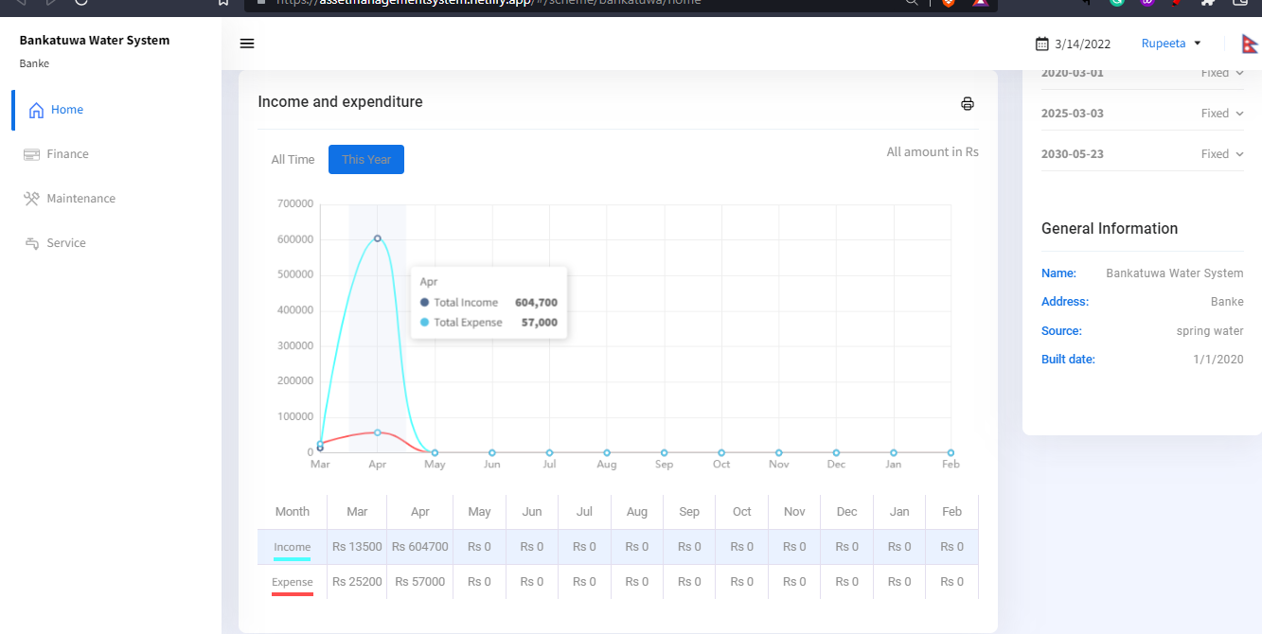

### 

### 5.1.2 Maintenance Cost Visualization

In the Visualization Graph of Maintenance Cost, users can view the maintenance cost for different years with respective months of the water system. There is a visualization graph for:

1. All Time
2. This year

#### 

#### 5.1.2.1 All Time

In the All-time visualization graph, users can view the maintenance cost like Expected unsegregated, expected consumable, expected labor, expected replacement, Actual unsegregated, actual consumable, actual labor, and actual replacement cost. When the cost of labor, consumables and/or replacement is known for a specific maintenance then these are added under respective titles. The visualization sums up all costs under these different titles for all maintenance actions for a period. But if separate costs are not known for a maintenance action then it is added as unsegregated (specific cost titles not separated). These two options for cost addition are mutually exclusive for one maintenance. The total cost of maintenance is the sum of all costs. But users can also separately see costs that are incurred or estimated for different titles if known and lump sum incurred or estimated cost when cost titles are not known. If the user clicks on the graph for Year 1, then they will be able to see the maintenance cost for that year. Likewise, to view other years' maintenance costs, users can click on the graph of different years.

Example:

|  |  |
| --- | --- |
| Type of cost | Cost |
| 1. Unsegregated | 100 |
| 1. Segregated | (C)+ (D)+ (E)= 43 |
| (C) Consumable | 25 |
| (D) Labour | 18 |
| (E) Replacement | 0 |
| TOTAL | (A)+ (B)= 143 |

***Note:*** *If you add the cost separately, it comes under the specific headings you have selected*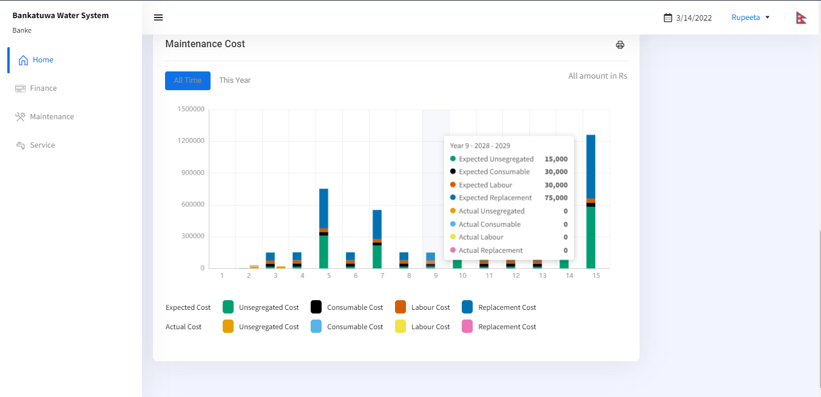

*( Expected consumable, Expected Labour, Expected Replacement ). But, if you add cost without separating, it comes under Expected unsegregated cost.*

*Basically, expected Unsegregated cost= Expected consumable + Expected Labour + Expected Replacement*

* Expected Consumable: is the expected cost of goods and repair costs required to fix machineries and other necessary equipment required for regular maintenance .
* Expected Labor: is the estimated cost of laborers required for maintenance.
* Expected replacement: is the estimated cost of complete replacement of machines or equipment after their failure.
* Actual unsegregated: is the total amount of actual costs, without the segregation in consumable, labor or replacement costs, while completing a maintenance action.
* Actual consumable: is the actual cost of goods and repair costs required to fix machineries and other necessary equipment in the process of actual, regular maintenance.
* Actual labor: is the actual cost of laborers used in the process of actual maintenance.
* Actual replacement: is the actual cost of complete replacement of machines or equipment after their failure.

#### 5.1.2.2 This year

In This year's visualization graph, users can view the Expected & Actual maintenance cost (Segregated and Unsegregated) for the current year with their respective months.

## 

## 

## 5.2 Finance

In the Finance tab, there are two main tabs. They are Visualization and Actual Income/Expenditure (Cashbook).

### 

### 5.2.1 Visualization

In the Financial data visualization graph, there is a visualization graph for All Time & This Year.

#### 

#### 5.2.1.1 All Time

In the All-time Financial visualization graph, users can view the financial data for the different years. On the right side of the tab, there is a visualization parameter that needs to be selected by the user in order to see the financial records in a graph for different years. Users can see Actual Income, Actual Expenses, Actual Cumulative Cash Flow, Expected Income, Expected Expenses, and Expected Cumulative Cash Flow.

Actual income: Sum of actual earnings or income received under different categories over a particular period.

Actual expenses: Sum of actual spending under different categories over a particular period.

Actual cumulative cash flow: Difference between actual income and actual expenses for a particular period carried over as a starting cash balance for the next period.

Expected income: Sum of expected earning or income under different categories for a future period.

Expected expenses: Sum of expected spending under different categories for a future period.

Expected cumulative cash flow: Difference between expected income and expected expenses for a future period carried over as starting cash balance for next period.

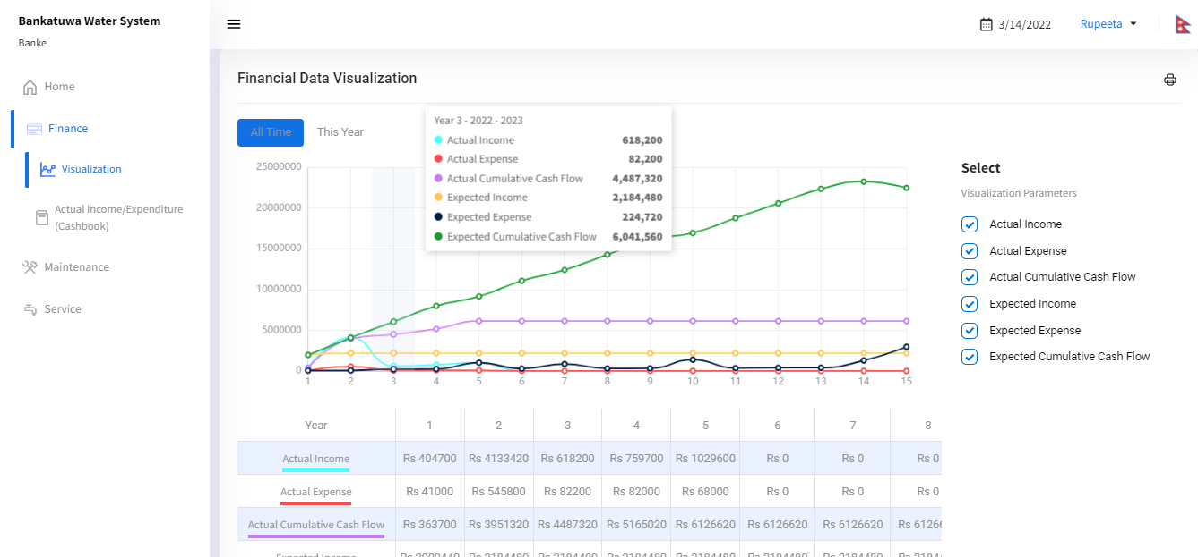

#### 5.2.1.2 This Year

In this year's financial data visualization graph, users can view the financial data for the current year with their respective months. On the right side of the tab, there is a visualization parameter that needs to be selected by the user in order to see the financial records in a graph for different months of the current year. Users can see Actual Income, Actual Expenses, Actual Cumulative Cash Flow, Expected Income, Expected Expenses, and Expected Cumulative Cash Flow. For a clear definition of the each title see section 5.2.1.1

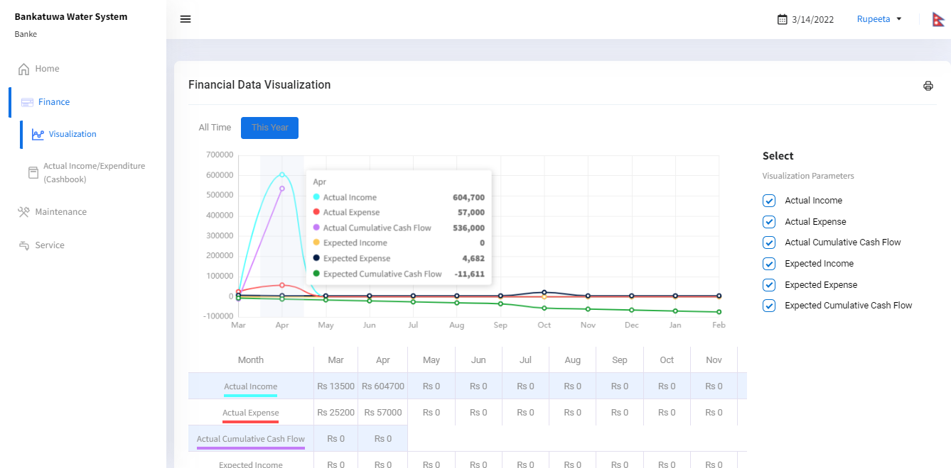

### 5.2.2 Actual Income/Expenditure (Cashbook)

In the cashbook tab, users can see the cash book record regarding income and expenses by Month & by dates for different years dates. This cashbook record shows the total amount and the previous month’s total per the different income and expense headings.

By Month

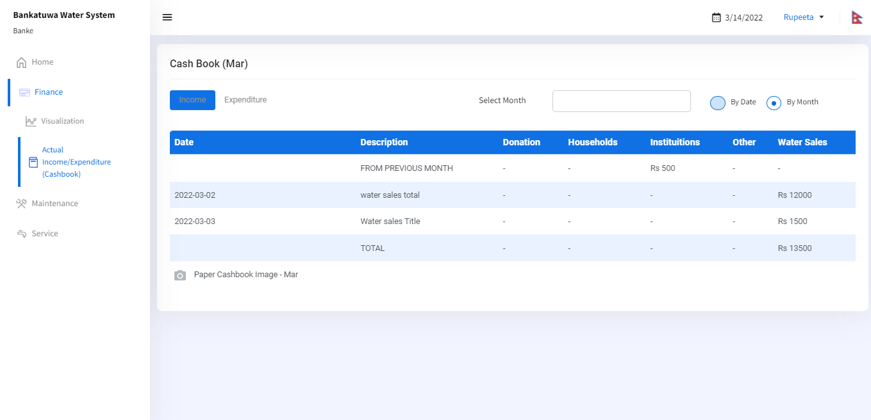

By Date

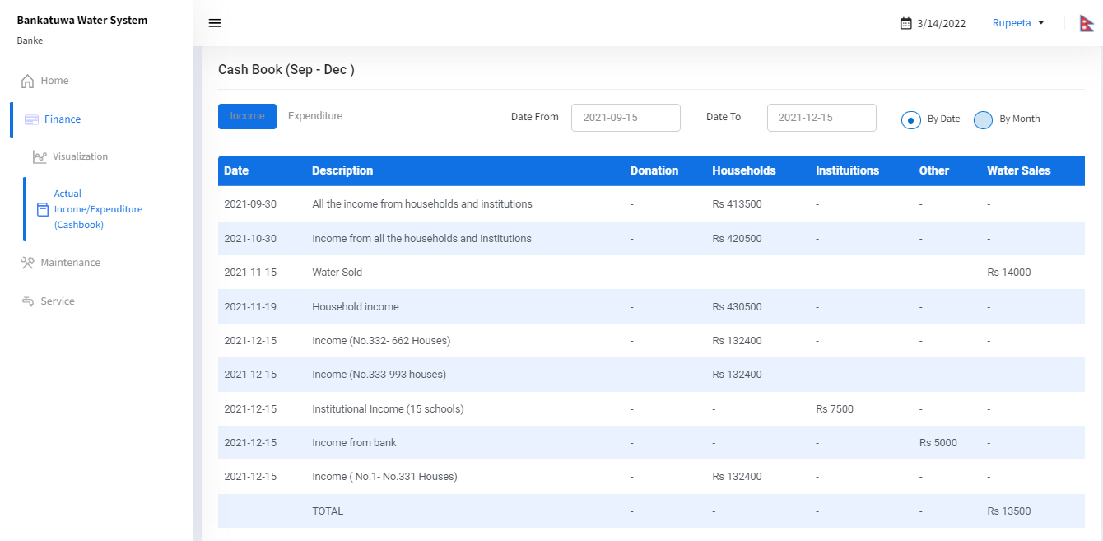

## 5.3 Maintenance

In the Maintenance tab, there are two main sub-tabs. They are Cost Visualization and Expected risks, activities & cost of Asset Components.

### 

### 5.3.1 Cost Visualization

In the Maintenance Cost Visualization graph, there is a visualization graph for All Time & This Year.

#### 

#### 5.3.1.1 All Time

In the All-time maintenance visualization graph, users can view the maintenance record data for different years. On the right side of the tab, there is a visualization parameter that needs to be selected by the user in order to see the maintenance records in a graph for different years. Users can see various maintenance costs, including Actual unsegregated, Actual consumable, Actual labor, Actual replacement, Expected unsegregated, Expected consumable, Expected labor, and Expected Replacement.

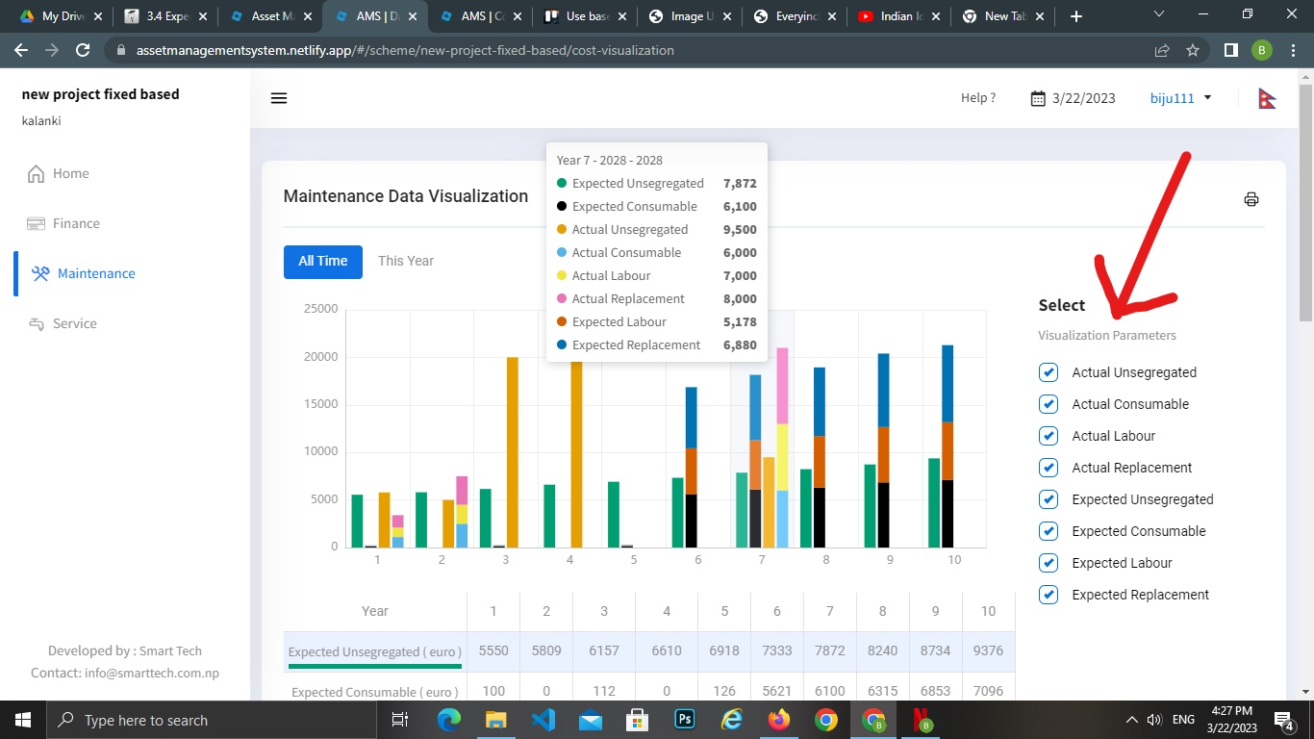

Maintenance Cost Distribution- Actual & Maintenance Cost Distribution- Planned data can be seen in the table below the maintenance cost visualization graph.

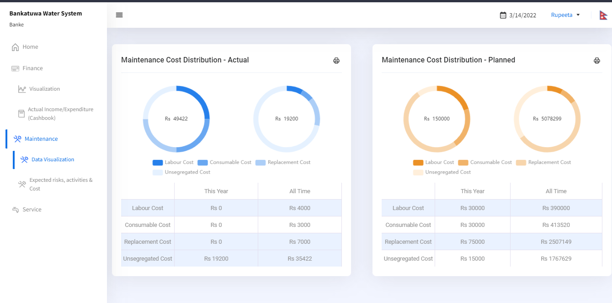

#### 5.3.1.2 This Year

In this year's Financial data visualization graph, users can view the financial data for the current year with the respective months. On the right side of the tab, there are visualization parameters that need to be selected by the user in order to see the maintenance records in a graph for different months of the current year. Users can see various maintenance costs, including Actual unsegregated, Actual consumable, Actual labor, Actual replacement, Expected unsegregated, Expected consumable, Expected labor, and Expected Replacement.

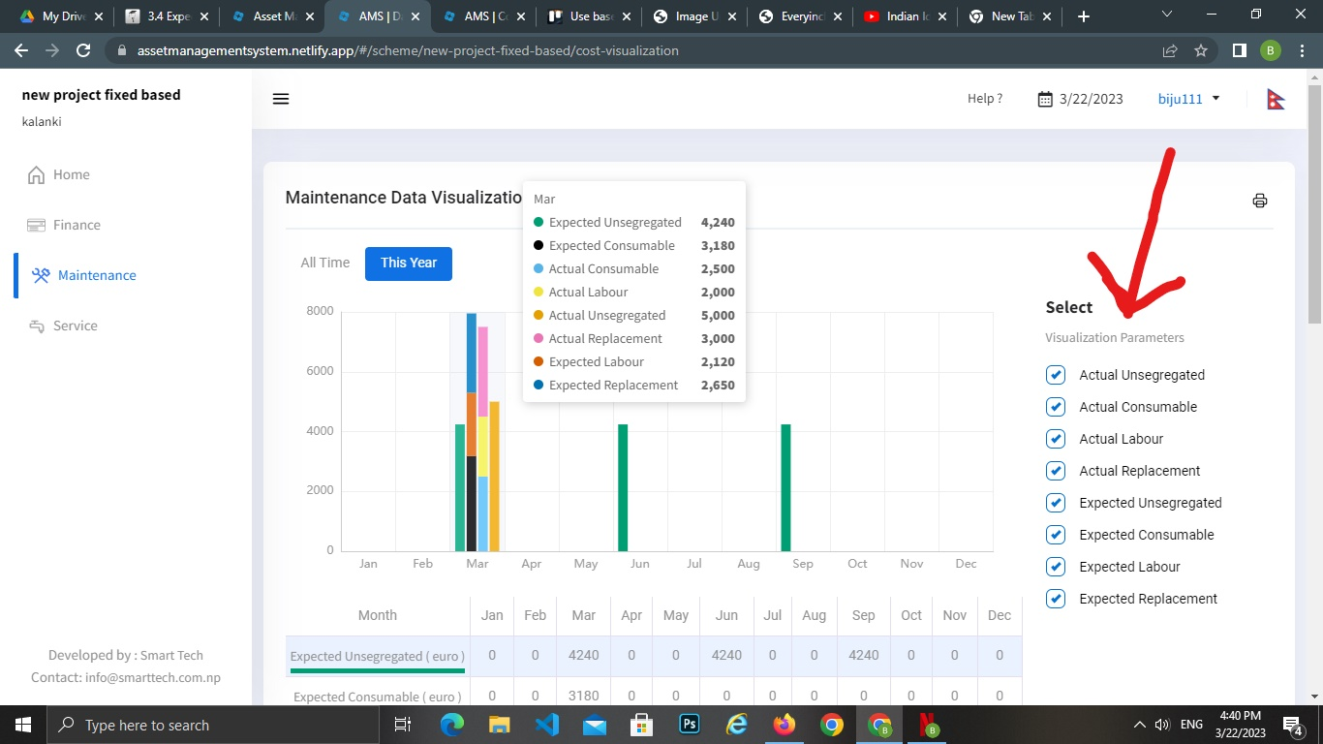

### 

### 5.3.2 Expected risks, activities & Cost

In the Expected risks, activities & Cost, users can see the list of Asset Components with the description of Possible Failure, Mitigation, Responsible, Risk, Life span, and Cost. If the users click on the Risk button, they will be able to see the brief descriptions of asset failures with a risk score for each respective asset component with a component picture. Edits need to be done directly in the app or the configuration panel.

Possible failure: Possible reason in which the component can fail

Mitigation:Here, mitigation refers to the types of action that needs to be done regarding the failure of the component to which maintenance action has to be done later on. Select one of the mitigation from the given lists:.

Reactive: One reacts when the asset breaks down or fails.

Inspection: One uses regular pre-planned inspections to determine the state of the assets, and plan maintenance based on that.

Preventive: One does maintenance when a certain specified parameter reaches a certain value/level (e.g. replacement of a valve after 10,000 liters or water supplied).

Risk: Resulting risk calculated from two parameters. First, the probability of the component to fail (high, medium, low, minimal) and second, its effect on the system or service when this failure happens (total loss of functionality, reduction of system functionality, reduction of parts functionality, hardly any effect).

Life span: Duration of time the component is expected to function properly.

Cost: Cost of maintenance of the component when the failure happens.

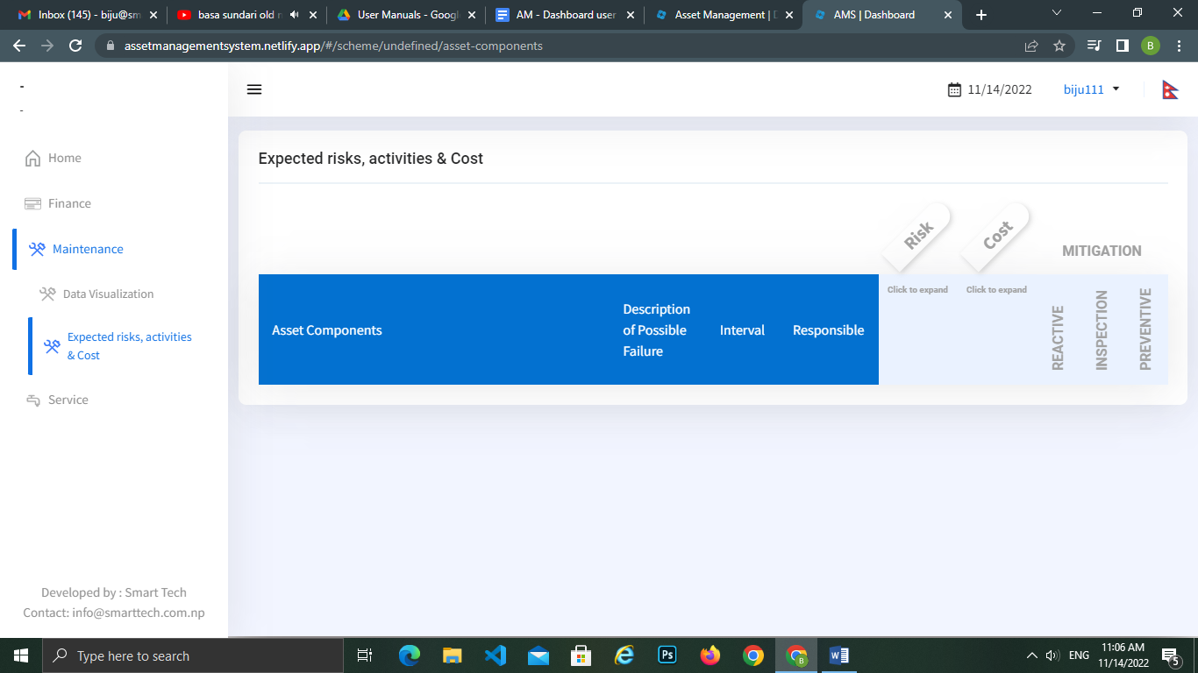

Similarly, if the users click on the Cost button, they will be able to see the required maintenance cost of an asset component.

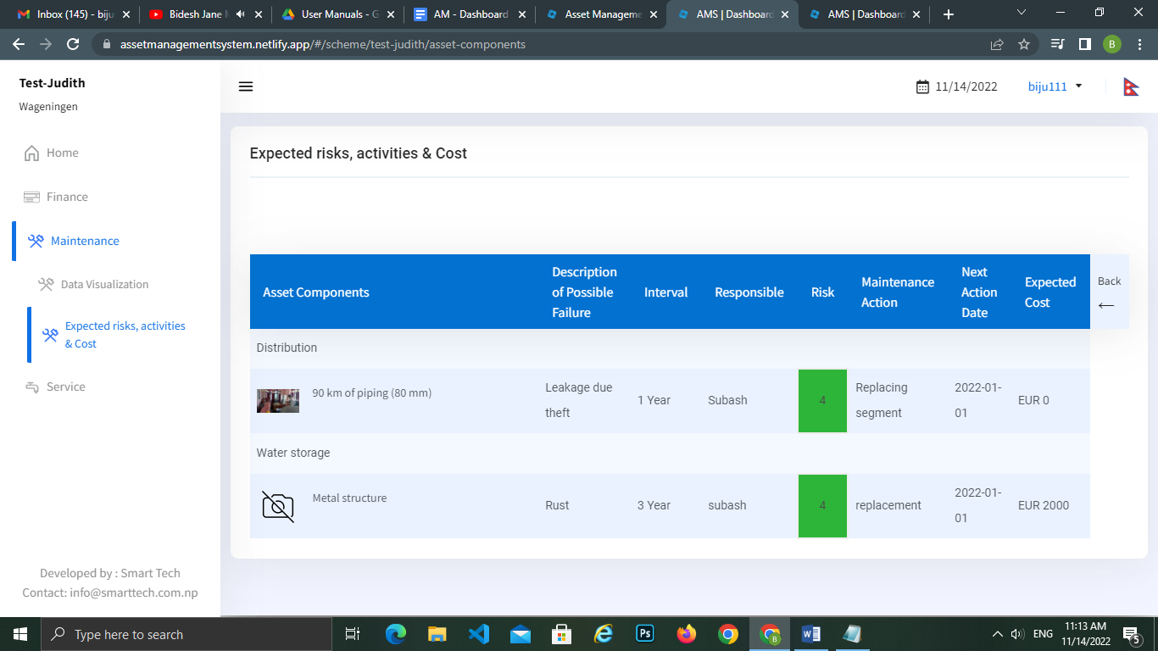

## 5.4 Service

In the Service Tab, there are two main sub-tabs. They are Supply Visualization and Quality Test Results.

### 

### 5.4.1 Supply Visualization

In the Supply Visualization graph, users can view the water supply for All time, This Year, This Month & for This week by clicking on the tabs below the title heading Supply Visualization.

By selecting the visualization parameters on the right side of the dashboard, users will be able to see the yearly average water dispensed from the distribution tank, water dispensed fthe rom distribution tank, Non-revenue Water & Revenue water. Users can view water supply data by selecting different year dates.

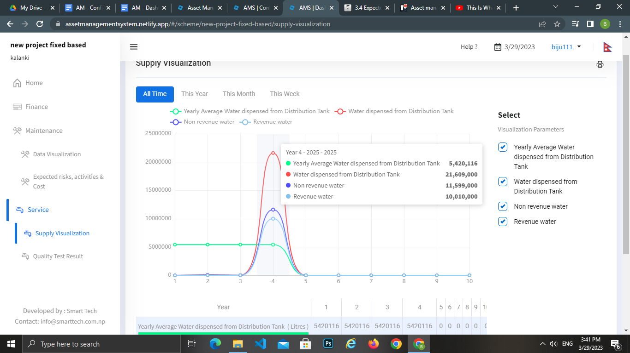

Factors included in the supply visualization graph.

1. The total amount of water that will be dispensed from the system (either entered through your mobile app or configuration panel under the Service tab).
2. Sales record recorded with cash book income transactions (either entered through your mobile app or configuration panel under the Cashbook tab).
3. Non-revenue water is calculated on the basis of Total Water Dispensed from the system and the total amount of income generated by the water sales on a particular date of the year (currently it shows by week, month, year, and all time) data. It is the difference between water supplied and the real-time cash book income collection of the water.

IMPORTANT: The Supply visualization of Non-revenue and Revenue Water only becomes visible when both data on Water Sales under Cashbook transactions and Water Supply records under Service have been inserted through Mobile app and/or Configuration panel.

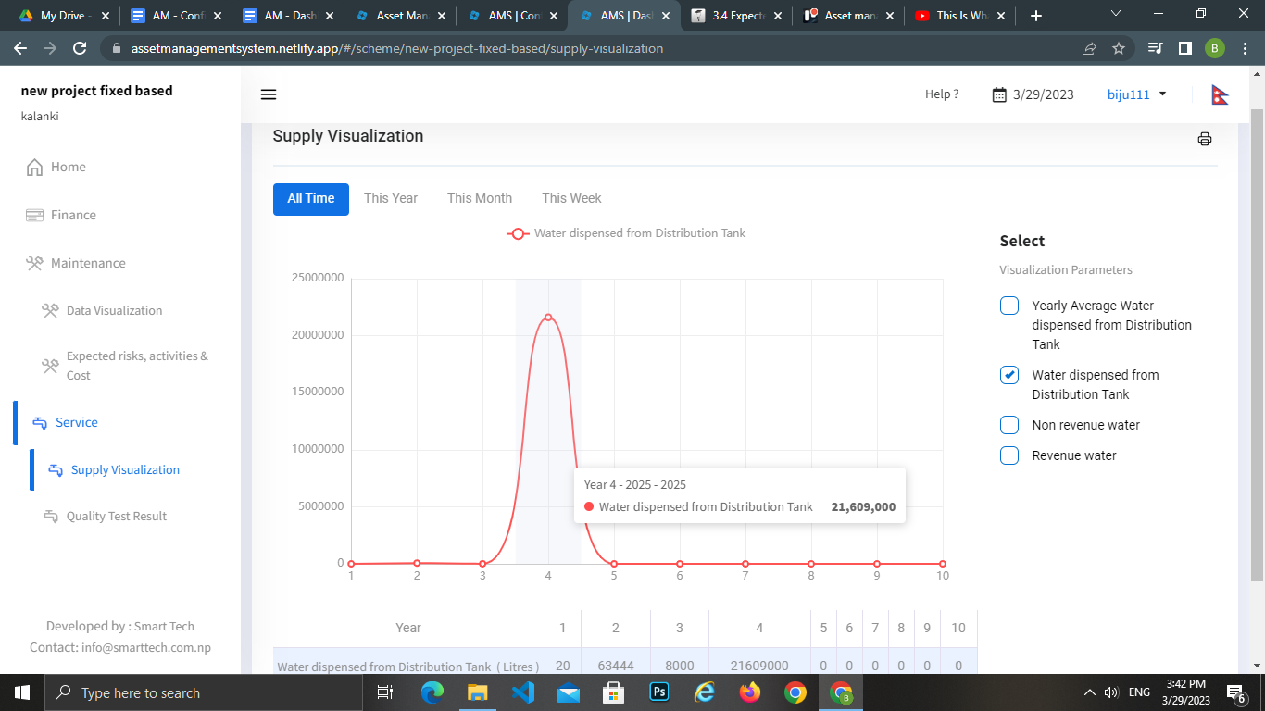

The term “water dispensed from distribution tank” is the amount of water that has been supplied from the water system.

### 

### 5.4.2 Quality Test Result

In the Quality Test Result, users can view the Quality test result of Water for All Time & This Year. Water quality parameters are the chemical, physical, biological and other properties that can be tested or monitored to determine the actual water quality. By selecting the different water parameters, users can see the test results per indicator.

#### 5.4.2.1 Quality Test Result

By selecting the visualization parameters on the right side of the dashboard, users will be able to see between the different parameters (chemical, physical, and others) to be displayed. To avoid confusion, only one parameter will be displayed on the screen. To see a different parameter, you need to select it on the right side of the screen. You can select to visualize the quality test results by All Time, or This year.

In the graph, the Y -axis represents the values for the given units. The X-axis shows the data for which the entries were added.

A horizontal line shows the maximum and minimum values for the NDWQ standard to serve as a reference for the test results.

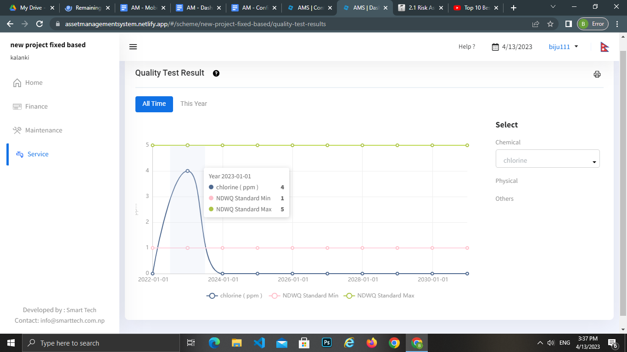

#### 

## 

## 5.5 Change Language

There is an availability of two languages: English and Nepali for the web dashboard. Users can select the language by:

* Clicking on the top of the right corner where there is an icon of Flag

## 5.6 Logout

Users can logout from the web dashboard by:

* Clicking on the User name placed on the right side of the panel near the language selection and clicking on the Logout displayed text.

For any further information, please contact to the email address below:

Email: [info@smarttech.com.np](mailto:info@smarttech.com.np)

**Thank you**